**Course _______Specialist______ Year __12_____**

Student name: ________________ Teacher name: ________________

Date: 17 June Weds p3 (Advo)

**Task type: Response**

**Time allowed for this task: _____45______ mins**

**Number of questions: _____7______**

**Materials required:** Calculator with CAS capability (to be provided by the student)

Standard items: Pens (blue/black preferred), pencils (including coloured), sharpener, correction fluid/tape, eraser, ruler, highlighters

Special items: Drawing instruments, templates, notes on one unfolded sheet of   
A4 paper, and up to three calculators approved for use in the WACE examinations

**Marks available: __42____ marks**

**Task weighting: _12___%**

**Formula sheet provided: Yes**

**Note: All part questions worth more than 2 marks require working to obtain full marks.**

**Q1 (3.3.5- 3.3.6) (2 & 3 = 5 marks)**

Consider a car A that has an initial position vector  km and moving with a constant velocity of  km/h.

1. Determine the position vector in 5 hours from now.

|  |
| --- |
| **Solution** |
|  |
| **Specific behaviours** |
| 🗸 multiplies velocity by time  🗸 states position vector |

Consider a second car B that has an initial position  km and a constant velocity of  km/h.

1. Determine if the two cars collide and if they do the position vector of this point of collision and the time it occurs.

|  |
| --- |
| **Solution** |
| Collide at (47,21) Km |
| **Specific behaviours** |
| 🗸 obtains expression for position vectors in terms of time  🗸 solves for i components  🗸 solves for j component and states pt of intersection |

**Q2 ( 3.3.1, 3.3.3) (3 & 2 = 5 marks)**

Consider the two lines 

1. Determine the point of intersection, if any.

|  |
| --- |
| **Solution** |
| Intersect at (5,-1,-1) |
| **Specific behaviours** |
| 🗸 uses two parameters  🗸 sets up three simultaneous equations  🗸 states pt of intersection |

1. Determine to the nearest degree the acute angle between the two lines.

(Consider the plane that contains both lines)

|  |
| --- |
| **Solution** |
|  |
| **Specific behaviours** |
| 🗸 uses vectors parallel to lines  🗸 states acute angle between lines |

**Q3 (3.3.8) (2, 3 & 3 = 8 marks)**

Consider a plane that contains the point  and has a normal vector .

1. Determine the vector equation of the plane.

|  |
| --- |
| **Solution** |
|  |
| **Specific behaviours** |
| 🗸 uses dot product with normal  🗸 right hand side correct scalar |

1. Determine the point of intersection of the line  with the plane above.

|  |
| --- |
| **Solution** |
|  |
| **Specific behaviours** |
| 🗸 subs line into plane equation  🗸 uses dot product and solves for parameter  🗸 states pt of intersection, allow approx. decimal |

1. Determine the distance of point  from the plane above.

|  |
| --- |
| **Solution** |
| Choose any point on plane (0,0,26/8)    OR |
| **Specific behaviours** |
| 🗸 chooses any point on plane OR line parallel to normal through point  🗸 uses dot product  🗸 states approx distance |

**Q4 ( 3.3.9-3.3.10) (3 & 3 = 6 marks)**

1. Solve the following system of linear equations. Working must be shown.



|  |
| --- |
| **Solution** |
|  |
| **Specific behaviours** |
| 🗸 eliminates one variable from two equations  🗸 eliminates two variables from one equation  🗸 solves for all three variables |

Consider the constants  in the system below.



1. Determine all the value(s) of such that:
2. There will be an unique solution
3. There will be infinite solutions
4. There will be no solutions

`

|  |
| --- |
| **Solution** |
|  |
| **Specific behaviours** |
| 🗸 obtains row with two variables eliminated  🗸 determines values for infinite solns  🗸 determines values for unique and no solution |

**Q5 (3.3.11 – 3.3.15) (3 & 3 = 6 marks)**

Consider an object moving with acceleration  at time  seconds. The initial velocity is and initial displacement .

1. Determine the position vector at time  seconds.

|  |
| --- |
| **Solution** |
|  |
| **Specific behaviours** |
| 🗸 integrates to find velocity with a vector constant  🗸 integrates to find position with a vector constant  🗸 solves correctly for both vector constants |

1. Determine the distance travelled in the first 10 seconds.(One decimal place)

|  |
| --- |
| **Solution** |
| Distance =75.6 metres |
| **Specific behaviours** |
| 🗸 uses magnitude of velocity(shown)  🗸 states integral  🗸 states distance to one decimal place |

**Q6 (3.3.15) (3 & 2 = 5 marks)**

Consider an aircraft with position vector  at time  hours. At the top of a building stands an antenna with the position vector of the highest point being .

1. Determine the times the aircraft is less than 100 km from the top of the antenna.

|  |
| --- |
| **Solution** |
| **Time between zero and 4.57 seconds** |
| **Specific behaviours** |
| 🗸 uses vector subtraction  🗸 determines expression for distance apart  🗸 solves for less than 10 km and states non negative values of time |

1. Determine the closest approach of the aircraft and the time it occurs.

|  |
| --- |
| **Solution** |
| Min distance at t=zero seconds |
| **Specific behaviours** |
| 🗸 graphs or uses fmin of expression for distance apart from part a  🗸 states t=0 & 14.5 km |

**Q7 (3.3.15) (4 & 3 = 7 marks)**

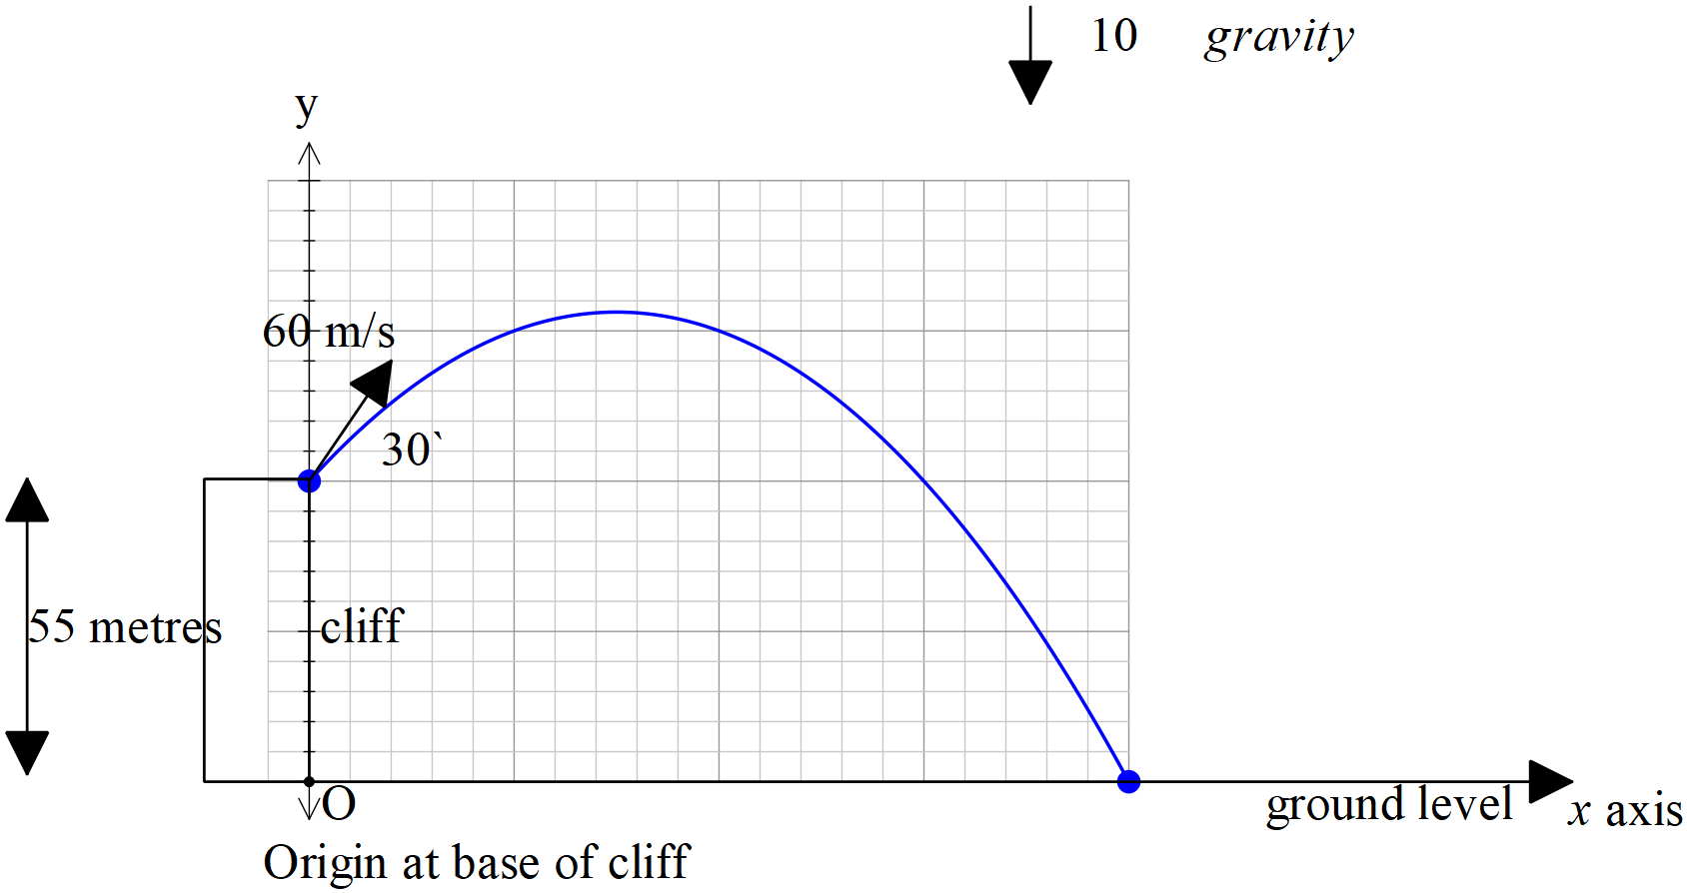

Consider a football that is kicked off the top of a cliff of height 55 metres with an initial speed of 60 m/s at an angle of  with the horizontal. The acceleration due to gravity is .

1. Show using **vector integration** how to determine the exact cartesian equation of the path using the base of the cliff as the origin.

|  |
| --- |
| **Solution** |
|  |
| **Specific behaviours** |
| 🗸 integrates acceleration and solves for vector constant  🗸 integrates velocity and solves for vector constant  🗸 obtains expression for t in terms of x  🗸 obtains exact cartesian equation |

1. Determine the time, one decimal place, taken to hit the ground and the horizontal distance of this point from the base of the cliff.

|  |
| --- |
| **Solution** |
|  |
| **Specific behaviours** |
| 🗸equates y parametric equation to zero  🗸 solves for time to one decimal place  🗸 states approx. horizontal distance |

**End of test**